Civil war in Liberia

UNSC Resolution: | 1509.2511
Date of adoption: | 19 September 2003
Operative paragraph: | 25
Demand number: | 1509.2511

Sarah-Myriam Martin-Brûlé

Wording of demand

undertake, with the assistance of UNMIL, appropriate actions to sensitize the Liberian population to the rationale of the measures in this resolution, including the criteria for their termination
****This demand is in UNSC Resolution 1521, 22 December 2003, op. paragraph 25 *****

List of addressees of the demand
The Government of Liberia

Short-term compliance

Description of the addressee(s)’ conduct

‘”Many fighters mistakenly assumed that when they turned in their arms they would instantly receive their cash payment of USD 150. This misinformation was clearly attributed to inadequate sensitization regarding the DDRR process. As dissatisfaction boiled over, the ex-combatants began brandishing their weapons and subsequently took over Camp Scheiffelin. Shots were fired and many disgruntled fighters returned to Monrovia, riding atop vehicles and waving their guns. Angry ex-combatants set up roadblocks and a general period of rioting ensued in the capital and surrounding areas for the following two days, resulting in the deaths of nine citizens (assumed to be ex-GoL fighters).6

Nichols, Ryan 2004. ‘Disarming Liberia: Progress and Pitfalls”. Small Arms Survey.
http://www.smallarmssurvey.org/files/sas/publications/b_series_pdf/AA/Part%20I%2004%20Liberia.pdf

“53. Given the lack of evidence of arms shipments to Liberia, the Panel was keen to conclude specific cases of arms trafficking mentioned in earlier reports by obtaining the details of companies, individuals and States involved, and the routes by which arms and materiel were imported into Liberia. The Panel hoped that the National Transitional Government of Liberia would be forthcoming in its assistance to the
Panel, but that has not been the case. In particular, the Panel interviewed the Minister of Defence, Daniel Chea, who held the same post under former President Taylor. He maintained that he knew nothing about either the origins of the arms delivered under Taylor or the payments for them.
(…)
“On 17 December 2003, the programme was suspended after 12,664 ex- Government of Liberia combatants had been disarmed and 8,686 assorted weapons had been collected. It was subsequently agreed by UNMIL and the leadership of the three factions, LURD, MODEL and ex-Government of Liberia forces, that the
disarmament, demobilization, rehabilitation and reintegration process would resume only after all necessary arrangements were in place to ensure a well-prepared, better coordinated and secure operation. The resumption of the programme was contingent on the following preconditions having been met: sufficient UNMIL troop deployment to provide adequate security, implementation of an extensive information and sensitization campaign for combatants, establishment of cantonment sites with operational readiness for demobilization services and provision by the three armed factions of lists of their fighters, locations and weapons”

Report of the Secretary-General pursuant to Security Council resolution 1521 (2003) regarding Liberia, 26 May 2004. S/2004/428
http://wwww.reliefweb.int/rw/RWFiles2004.nsf/FilesByRWDocUNIDFileName/HMYT-5ZLMPR-unsc-lib2-26may.pdf/$File/unsc-lib2-26may.pdf

“By mid-2004, doubts were being raised about the commitment of the NTGL to governance reform. Poor choices in public finance management were delaying RFTF delivery and economic recovery remained sluggish. Reports of widespread corruption were appearing in the Liberian media and the various factions within the NTGL accused each other of siphoning off state finances for personal gain, increasing fears for the stability of the peace process. With mounting evidence of government manipulation of the public coffers, donors were increasingly hesitant about putting resources directly under NGTL control. In December 2004, the International Crisis Group called for a radical international approach in Liberia, proposing that this should include international assumption of responsibility for revenue collection.”

Renata Dwan & Laura Bailey. 2006. Liberia’s Governance and Economic Management Assistance Programme (GEMAP) ;A joint review by the Department of Peacekeeping Operations’ Peacekeeping Best Practices Section and the World Bank’s Fragile States Group, May 2006.

http://www.gemapliberia.org/files/WB_Joint_review_of_GEMAP.pdf

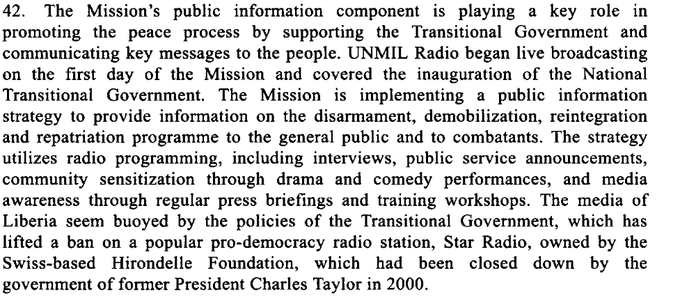

Fifth Progress Report of the Secretary General on the Situation in Liberia, 15 December 2003, S/2003/1175

Assessment

Short-term compliance
No or marginal compliance (1) | X Medium low compliance (2) | Medium high compliance (3) | Full or almost full compliance (4)

Considerations underlying the assessment

Within the six months following the adoption of the demand, the demand addressee did not take all the appropriate actions to sensitize the Liberia population to the rationale of the measure in this resolution.

Medium-term compliance

Description of the addressee(s)’ conduct

“49. The Ministry has launched a media campaign to raise public awareness of the Kimberley Process Certification Scheme and warn of the penalties for illegal mining and trafficking of diamonds. Posters, radio spots and public announcements have been developed and broadcast throughout Monrovia and Robertsfield International Airport. Nevertheless, there is much to be done with regard to the sensitization of diggers, dealers, brokers and exporters to the details of the internal control mechanism. »
http://www.gacliberia.com/reports/unpanelreport_121506.pdf

“65. However, when the political will exists, the National Transitional Government of Liberia has been able to implement the rule of law. In mid-2005, FDA, UNMIL and civil society (in particular, the Sustainable Development Institute, Conservation International and Fauna and Flora International) persuaded about 5,000 illegal squatters to vacate Sapo National Park (ibid.). A thorough awareness-raising campaign informed the miners and hunters . many of whom were ex-combatants . that they had to leave. This message was backed up by the authority of the FDA officers, including a site visit by the Managing Director himself, and by UNMIL peacekeepers.”

S/2005/745, 7 December 2005
http://www.undemocracy.com/S-2005-745.pdf

“Serious efforts are being made to address the worrying problems of crime, especially armed robberies, mob violence and rape. UNMIL has joined the GoL and other partners to launch nationwide campaigns against rape and other forms of crime.”

UNMIL, Presskit.
http://unmil.org/documents/insideunmil/presskit2008.pdf

“There is reported to be growing resentment among some combatants who perceive themselves as abandoned by their leaders now in the NTGL in Monrovia.”

Amnesty International. 2004. “Document - Liberia: One year after Accra - immense human rights challenges remain”
http://www.amnesty.org/en/library/asset/AFR34/012/2004/en/0c194f7a-d59d-11dd-bb24-1fb85fe8fa05/afr340122004en.html

“4. The National Transitional Government of Liberia took measures against a number of reported cases of corruption. On 12 July, following allegations of fraud at the Bureau of Maritime Affairs, the Chairman of the National Transitional Government, Charles Gyude Bryant, suspended the Commissioner of the Bureau and dismissed the representative of Liberia to the International Maritime Organization. The two officials, together with two others from the Bureau, are alleged to have misappropriated more than $4 million and have been charged with “economic sabotage and fraud of the internal revenue of Liberia”

Eighth progress report of the Secretary-General on the United Nations Mission in Liberia, 1 September 2005 , S/2005/560

Assessment

Medium-term compliance
No or marginal compliance (1) | Medium low compliance (2) | X Medium high compliance (3) | Full or almost full compliance (4)

Considerations underlying the assessment

Within the two years following the adoption of the demand, the demand addressee took significant actions to sensitize the Liberia population to the rationale of the measure in this resolution.

Depth of demand

Assessment

Level of depth of demand
Low depth of demand (1) | X Medium depth of demand (2) | High depth of demand (3)

Considerations underlying the assessment

By taking appropriate actions to sensitize the Liberian population to the rationale of the measures in this resolution, including the criteria for their termination, some members of the government could risk to put to light their own illegal activities, hence jeopardizing their chances to win or to stay in power.

Level of confidence about coding decisions

Level of confidence about coding decision
Extremely high | X High | Moderate

Comments to IPI (if any)

“According to the CPA, the NTGL was intended as ‘an all-inclusive Transitional Government’. Article XXVI (4) of the CPA stipulates that government positions would be allocated to the various warring parties according to a negotiated formula22. However, the politically heterogeneous character and composition of the NTGL has had adverse effects on its coherence and cohesion as an effective, functional state. It has often lacked the requisite technical, administrative, managerial and governance frameworks for reconstruction.”
(…)
“Several factors inherent to the peace process combine to impede the NTGL from making use of good practices, or at least desisting from bad practices. Firstly, the NTGL is an uneasy ‘coalition’. It is heterogeneous, with mutual suspicion between the various former warring factions that constitute the government. Divisions within the government have been both vertical and horizontal, operating at both inter-factional and intrafactional levels. The uneasy and arguably conflicting composition of the NTGL has hampered its efficiency and cohesion. There are conflicting and bloated interpretations and expectations of the CPA. The NTGL has also been held back by the battle for jobs among the factions. A prominent faction chief and member of the NTGL echoed his dissatisfaction with the Chair of the NTGL (Gyude Bryant), noting that the CPA is a ‘contract signed between the factions to which Bryant is not a party. His role is simply to execute the contract’23 On his part, the Chair of the NTGL allegedly failed to hold regular Cabinet meetings. A senior member of the NTGL regretted the paucity of cabinet meetings since the inauguration of the government in October 2003.24 There have been several references to the lack of consultation and communication within government by a cross-section of Liberians”
(…)
“A major obstacle to Liberia’s post-conflict reconstruction during the transition period has been the presence of rampant and endemic corruption within the NTGL.”
(…)
“Serving ministers and the Chair of the NTGL were reported to have been directly
implicated in a secret deal signed in February 2005 between the NTGL and the West
African Mining Company (WAMCO), giving the company ‘exclusive rights to buy all
minerals in the western region, except those under contract, for ten years subject to
review.’ The contract has since been cancelled.”
(…)
“There are several other reports of corruption and disregard for the rule of law. The Chair
of the NTGL is reported to have also been involved in the violation of Stay Orders of
the Supreme Court of Liberia against the sale of iron ore stockpiles. It was similarly
reported that ‘the Liberia Mining Corporation (LIMINCO) award of concession to Mittal
Steel, a London HQ company, has also been under controversial circumstances and the
matter is currently before the Supreme Court.’
The pervasiveness of corruption in the transition government has led to the United
Nations, the European Commission, World Bank, IMF, and ECOWAS to establish the
Governance and Economic Management Assistance Programme (GEMAP). » (Ebo 2005 : 8-10).

Adedeji Ebo. 2005. “The Challenges and Opportunities of Security Sector Reform in Post-Conflict Liberia”. Geneva Centre for the Democratic Control of Armed Forces( DCAF) Occasional Paper- No.9. Geneva, December 2005

